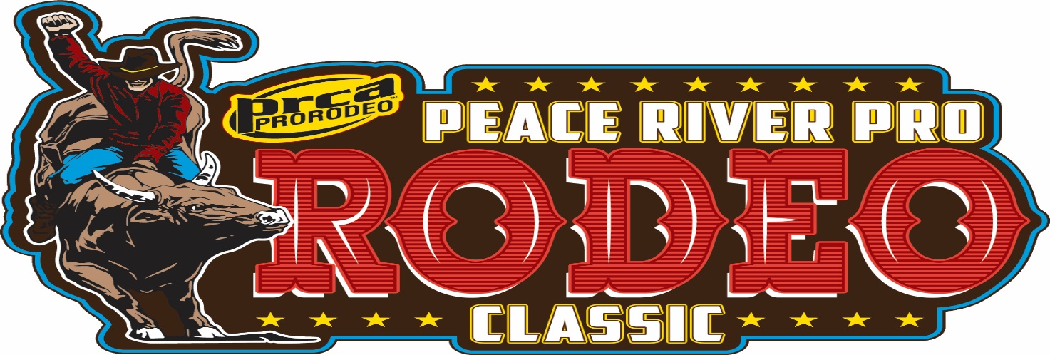

SPONSORSHIP OPPORTUNITIES

$5,500 + “PRESENTING SPONSOR”
- Barrel covers will have logo of choice
- 45 General Admission tickets for Saturday 7:00 pm /Sunday 2pm performances, January 27th and 28th, 2024
- 20 tickets for Saturday/Sunday performances (same times)
- Chute sign
- Recognition by Announcer throughout the rodeo performance
$5,000
- 30 General Admission tickets for Saturday 7:00 pm/Sunday 2pm performances, January 27th & 28th 2024
- 10 tickets for Saturday/Sunday performances (same times)
- Chute sign
- Recognition by Announcer throughout the rodeo performance
$2,500
- 15 General Admission tickets for Saturday 7:00 pm/Sunday 2pm performances, January 27th & 28th, 2024
- 6 tickets for Saturday/Sunday performances (same times)
- Chute sign
- Recognition by Announcer throughout the rodeo performance

$1,000
- 5 General Admission tickets for Saturday 7:00 pm/Sunday 2pm performances, January 27th & 28th, 2024
- 2 VIP tickets for Saturday/Sunday performances (same times)
- Name on group sign
- Name mentioned during Grand Entry
$500
- 2 General Admission tickets for Saturday 7:00 pm/Sunday 2pm performances, January 27th & 28th, 2024
- 2 tickets for Saturday/Sunday (same times)
- Name on group sponsor signage
$250
- 2 General Admission tickets for Saturday 7:00 pm/Sunday 2pm performances, January 27th & 28th, 2024

Other ($250- or less)
- 1 General Admission ticket for Saturday 7:00 pm/Sunday 2pm performances, January 27th & 28th, 2024

