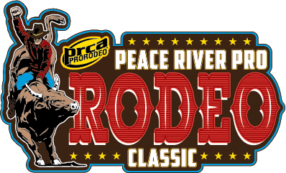

*2024 Vendor application*

Name of business: ____________________________________

Owner Name: __________________________________________________________________________________

Phone Number: _______________________________ Email: _______________________________________

Website: _____________________________________ Mailing Address: _____________________________

___________________________________________

Please indicate which type of vendor you will be participating as and mail $100 fees to:

Peace River Rodeo Association, Inc.
P.O. Box 835
Wauchula, FL 33873

*DEADLINE : Jan. 12th 2024

Foodl Vendor:
Please provide description of type of food you will be selling:
Retail Vendor:
please provide brief description of what you will be selling:

